# Poor Report Patterns

(This is not an exhaustive list of everything, just some of the more commonly seen issues in past semesters)

## Submitting a zip file but forgetting to submit a report at the top level.

Bad:

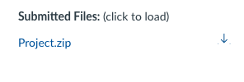

Good:

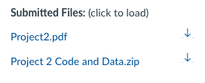

## Missing Indentation on paragraphs:

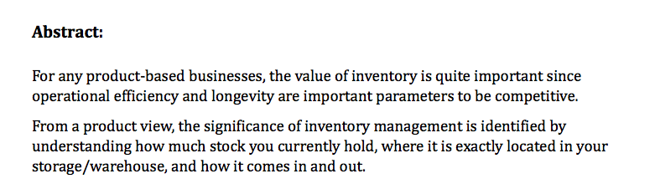

## Captions missing on images/charts:

## Charts that are hard to parse due to missing y labels, cutoff x-labels, and being unnecessarily large.

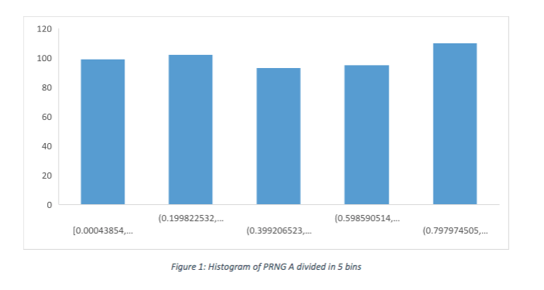

## Figures having labels and axes labels too small to read:

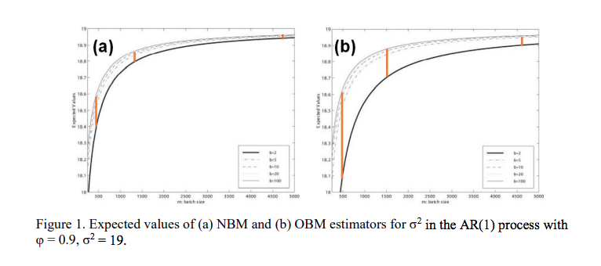

## Figures/Charts taking up unnecessarily large amounts of space and having far too much useless whitespace (shown are 4 consecutive pages of a report, in zoomed out view):

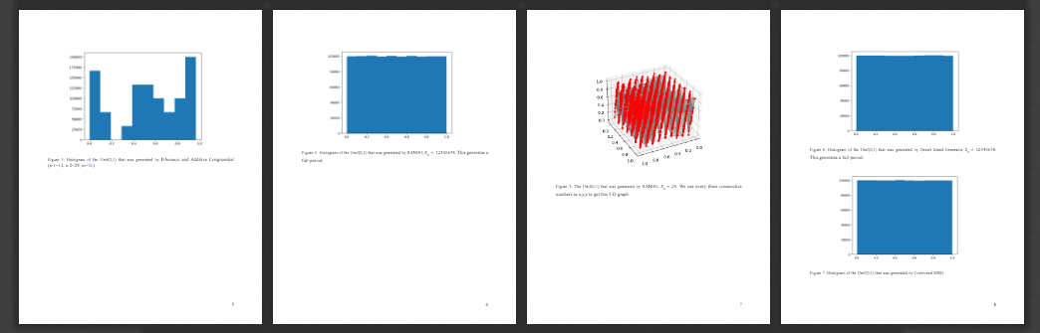

## Ugly screenshots of code in report:

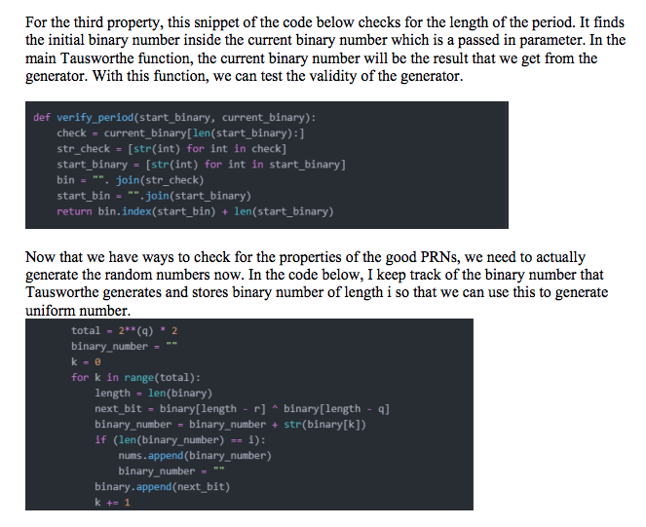

## Excel screenshots in the paper

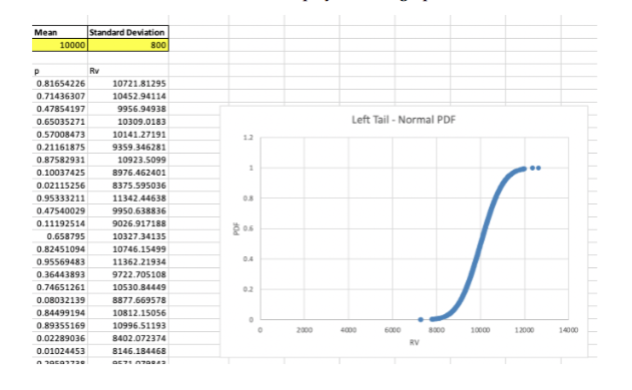

## Hard to read Arena diagrams in the paper

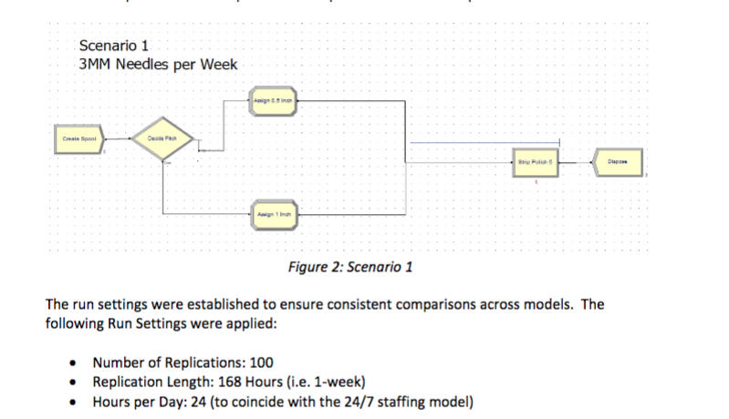

Poor editing of paper:

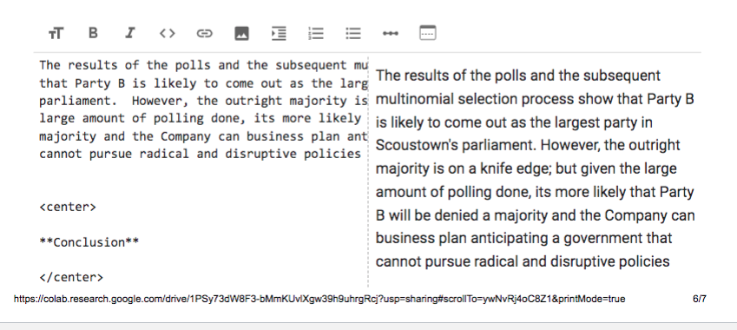

## Paper missing organizational section headings like Abstract, Background, etc… (also this paper is far too short and low effort)

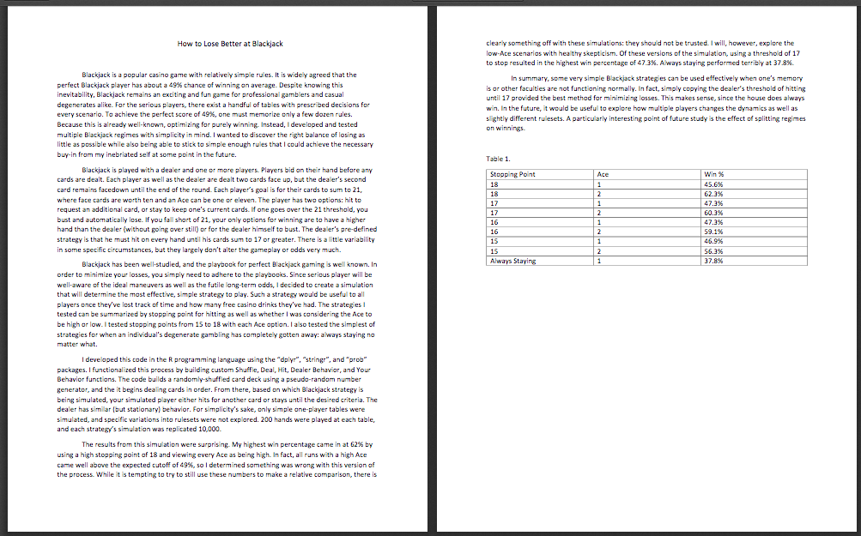

## Inconsistent line spacing:

